Software Requirement Specifications
Modeling Peer Interaction Networks to Identify Influential Learners



Submitted by
Name: Faisal Abbas
Roll No: F22BINFT1E02133

Submitted to
Dr. Mustafa Hameed

Department of Information Technology
Faculty of Computing
The Islamia University of Bahawalpur

Meeting Details
Sr No | Details | Date | Supervisor Signature
Summary
This document describes the SRS for the Peer Interaction Network Analyzer system. The objective of the system is to analyze and model peer interaction networks within online or classroom learning environments in order to find students who have strong influence among their peers.
The system aggregates and processes data from communication, participation, and collaboration to construct a graph network of the learner interactions. The work uses graph theories through NetworkX and machine learning techniques through Scikit-learn to identify key influencers, isolated learners, or learning clusters. This can help educators further improve collaboration, engagement, and personalized support in learning.
The key findings highlight that conventional approaches to finding influential learners were based on subjective observations and grade-based metrics, which cannot capture complex social dynamics within learning communities. This system provides insights based on data through network analysis and interactive visualizations.

Table of Contents
1. Introduction 5
1.1. Purpose 5
1.2. Scope 6
1.3. Product Perspective 7
1.4. User Characteristics 7
1.5. Similar apps and systems/Literature Review 8
1.6. Proposed Technologies 9
2. Requirements 9
2.1. Function Requirements 10
2.2. Non-Functional Requirements 18
3. Use Cases and Flow of Processes 20
3.1. Use Case 1 21
3.2. Use Case 2 25
3.3. Use Case 3 26
3.4. Use Case 4 27
3.5. Use Case 5 28
3.6. Use Case 6 29

4. References 30

1. Introduction
Learning environments in educational institutions are becoming more collaborative, in which peer interaction is crucial to sharing knowledge and developing skills. Understanding such dynamics helps educators to identify those students who would emerge as natural knowledge brokers, those at risk of isolation, and learning communities that have formed within the classroom.
This project involves the development of an intelligent system with the capacity to transform raw interaction data from learning management systems (LMS) into actionable insights about peer influence networks. The system will be able to use graph theory and machine learning algorithms to provide educators with tools that enhance student engagement, improve collaboration, and deliver personalized learning support.
1.1 Purpose
The main goals and objectives of the project are:

1. Analyze Peer Interaction Networks: Create full graph networks based on the interaction information of students, such as messages, collaborations, forum posts, and group activities.
2. Identification of Influential Learners: Centrality measures will be applied to rank student influence in the learning community, including degree, betweenness, eigenvector, closeness centrality, and PageRank.
3. Detect Learning Communities: Employ community detection algorithms, such as Louvain, to identify clusters of students who frequently interact, therefore showing natural study groups and collaboration patterns.
4. Identify Isolated Learners: Recognize those students who have low engagement or connectivity and may require additional support or intervention.
5. Interactive Visualizations: Create intuitive network visualizations that make complex social structures interpretable for educators.
6. Track Temporal Changes: Observe the evolving pattern of influence over time to identify emergent leaders and declining engagement.

7. Generate Actionable Recommendations: Intervene by providing educators with suggestions on how to help isolated learners and improve overall class engagement.

1.2 Scope
In Scope: Features to be Developed
• CSV/Excel data upload interface for peer interaction data
• Graph network construction using NetworkX library
• Centrality measure calculations: degree, betweenness, eigenvector, closeness, PageRank
• Community Detection with Louvain Algorithm
• Interactive network visualizations with Plotly
• Student analytics dashboard with influence scores and metrics
• Downloadable reports in CSV, Excel, and JSON format
• Search and filtering to explore learners
• MongoDB Database for storing persistent data
• Temporal network analysis for tracking influence changes
• Machine learning models for predicting future influential learners
• Isolated learner intervention recommendation system
• LMS integration support: Canvas, Moodle, Blackboard

Out of Scope (Features NOT Included):
- Real-time synchronous collaboration features
- Direct messaging between students
- Grade management or academic assessment
- Student authentication and access control (relies on LMS)
- Mobile application development
- Video conferencing integration
- Content management or course material hosting

1.3 Product Perspective
The Peer Interaction Network Analyzer is a stand-alone analytical tool that can be used in addition to the mainstream LMSs. It's designed to:
1. LMS Platform Integration: Ingest data from exports of popular platforms such as Canvas, Moodle, and Blackboard through standardized CSV/Excel formats.
2. Autonomous Operations: Operate as a purely web-based application accessible via conventional browsers, eliminating the need for installation on end-user devices.
3. Complement Current Tools: Provide insights to complement current educational analytics, rather than replacing existing assessment methods.
4. Scale with Institution Size: Be able to support everything from small classroom groups of 20-30 students, up to cohorts of 500+ students.

The system architecture follows a modular design with:
Frontend: Streamlit-based interactive web interface
Backend: Python-based analysis engine
Database: MongoDB for persistent storage
Analytics: NetworkX for graph analysis, Scikit-learn for machine learning

1.4 User Characteristics

User Role | Description | Technical Expertise | Primary Activities
Educator/Instructor | | Teachers, professors, or course instructors who want to understand student interaction patterns | Low to Medium | | Upload data, view visualizations, identify influential/isolated students, generate reports
Academic Administrator | Department heads or academic coordinators overseeing multiple courses | Low | View aggregate analytics, compare class engagement metrics, identify trends
Educational Researcher | | Researchers studying peer learning and social network dynamics in education | Medium to High | Export detailed metrics, analyze temporal patterns, study community formation
Learning Designer | Professionals designing course structures and collaborative activities | Medium | Medium | | Understand interaction patterns, design interventions, optimize group formations
IT Administrator | Technical staff managing system deployment and LMS integration | High | Configure LMS connections, manage data imports, maintain system

1.5 Similar Apps and Systems/Literature Review

Existing Systems Analysis

System | Features | Shortcomings
Gephi | Open-source network visualization, extensive graph analysis algorithms, plugin ecosystem | Steep learning curve, desktop-only application, no educational context, requires manual data preparation
NodeXL | Excel-based network analysis, social media integration, template-based reports | Limited to Excel users, Windows-only, not designed for educational environments, lacks predictive capabilities
SNAPP | Specifically designed for educational forums, Moodle integration | Limited to forum data only, no support for other interaction types, outdated interface, discontinued development
Learning Analytics Dashboard (LAD) | LMS-integrated, real-time data, student-facing insights | LMS-integrated, real-time data, student-facing insights
GISMO | | Moodle-specific, visual analytics, student tracking | Only works with Moodle, limited network analysis features, basic visualizations

Literature Review Summary
Research on social network analysis applied to education demonstrates the benefits derived from comprehending peer interactions.
1. Centrality and Academic Performance: Positive correlations were obtained by studies between network centrality measures and academic outcomes (Gašević et al., 2019).
2. Community Detection in Learning: The Louvain algorithm effectively identifies study groups and collaborative clusters in educational settings.
3. Temporal Network Analysis: The temporal analysis of networks shows not only the development of a network but also indicates certain periods that are most important for interventions and supporting either the individual or the whole network.
4. Predictive Analytics: Machine learning models predict at-risk students based on network features (Baker & Inventado, 2014).

Identified Gaps Addressed by This Project
1. Unified Platform: Combines network analysis, visualization, and prediction in one tool
2. Educational Focus: Designed specifically for learning environments with relevant metric
3. Accessibility: Web-based interface requiring no technical expertise
4. Temporal Analysis: Tracks changes over time with predictive capabilities
5. Intervention Support: Provides actionable recommendations for educators

1.6 Proposed Technologies

Category | Technology | Purpose
Frontend | Streamlit | Interactive web application framework
Backend | Python 3.11 | Core programming language
Database | MongoDB | Persistent data storage
Network Analysis | NetworkX | Graph construction and analysis
Community Detection | python-louvain | Louvain algorithm implementation
Machine Learning | Scikit-learn | Predictive modeling and classification
Data Processing | Pandas, NumPy | Data manipulation and computation
Visualization | Plotly, Matplotlib, Seaborn | Interactive charts and graphs
File Handling | openpyxl | Excel file import/export
ORM | SQLAlchemy | Database abstraction layer

2. Requirements
The Peer Interaction Network Analyzer system provides comprehensive functionality in the analysis of student interaction networks. Its core functionality includes data ingestion from diverse sources, such as CSV files, Excel, and exports from LMSs; network building and analysis via graph theory algorithms; the identification of influential and isolated learners using centrality measures; community detection to uncover natural learning groups; and the temporal tracking of changes in influence.
The system produces interactive visualizations that enable intuitive exploration of network structures by educators. Machine learning models forecast future influential learners and detect students at risk due to declining engagement. An intervention recommendation engine suggests ways of supporting isolated learners and improving overall class collaboration.

2.1 Functional Requirements
FR001: Data Upload

Name: FR001 Data Upload Interface
Purpose: Allow users to upload peer interaction data from CSV or Excel files for analysis.
User(s): Educator, Academic Administrator, Educational Researcher
Input:
File: CSV or Excel (.xlsx) file containing interaction records
Source Column: Column name identifying the student initiating interaction
Target Column: Column name identifying the student receiving interaction
Weight Column (Optional): Column indicating interaction strength/frequency
Interaction Type Column (Optional): Column categorizing type of interaction
Timestamp Column (Optional): Column with date/time of interaction

Output:
Confirmation message with number of interactions loaded
Data preview showing uploaded records
Validation errors if data format is incorrect

FR002: Sample Data Generation
Name: FR002 Sample Data Generation
Purpose: Generate realistic sample interaction data for testing and demonstration purposes.
User(s): Educator, Educational Researcher
Input:
Number of Students: Integer between 20-100
Number of Interactions: Integer between 100-1000

Output:
Generated interaction dataset with realistic patterns
Includes built-in influencers and isolated learners for demonstration

FR003: Network Construction
Name: FR003 Build Interaction Network
Purpose: Construct a graph network from uploaded interaction data representing peer relationships.
User(s): System (automatic upon data upload)

Input:
Processed interaction DataFrame
Column mappings for source, target, and optional weight

Output:
NetworkX graph object with nodes (students) and edges (interactions)
Edge weights based on interaction frequency or specified weight column

FR004: Centrality Calculation
Name: FR004 Calculate Centrality Measures
Purpose: Compute multiple centrality metrics to quantify student influence within the network.
User(s): System (automatic), Educator, Researcher

Input:
Constructed network graph

Output:
Degree Centrality: Number of direct connections
Betweenness Centrality: Role as bridge between other students
Eigenvector Centrality: Connections to other influential students
Closeness Centrality: Average distance to all other students
PageRank: Importance based on link structure
Composite Influence Score: Normalized aggregate of all measures

FR005: Community Detection
Name: FR005 Detect Learning Communities
Purpose: Identify clusters of students who frequently interact, revealing natural study groups.
User(s): Educator, Academic Administrator

Input:
Constructed network graph

Output:
Community assignment for each student
Number of communities detected
Modularity score indicating community quality
Community statistics (size, average influence, member list)

FR006: Influential Learner Identification
Name: FR006 Identify Key Influencers
Purpose: Rank and display the most influential students based on centrality measures.
User(s): Educator, Academic Administrator

Input:
Calculated centrality metrics
Number of top influencers to display (default: 10)

Output:
Ranked list of influential learners
Influence scores and centrality breakdown
Visual highlighting in network diagram

FR007: Isolated Learner Detection
Name: FR007 - Identify Isolated Learners
Purpose: Detect students with low connectivity who may need additional support.
User(s): Educator, Learning Designer

Input:
Calculated centrality metrics
Isolation threshold percentile (default: 15%)

Output:
List of potentially isolated learners
Warning indicators for very low connectivity
Connection count and influence score for each
FR008: Network Visualization
Name: FR008 Interactive Network Visualization
Purpose: Display the peer interaction network as an interactive graph for exploration.
User(s):Educator, Academic Administrator, Researcher

Input:
Constructed network graph
Centrality metrics
Community assignments
Color By: Option to color nodes by community or influence score
Size By: Option to size nodes by influence, degree, or uniform

Output:
Interactive Plotly network diagram
Node hover information showing student metrics
Zoomable and pannable interface

FR009: Analytics Dashboard
Name: FR009 Learner Analytics Dashboard
Purpose: Provide comprehensive analytics view with charts and statistics.
User(s): Educator, Academic Administrator, Researcher

Input:
All calculated metrics and network statistics

Output:
Network statistics overview (nodes, edges, density, clustering)
Centrality comparison bar chart
Influence score distribution histogram
Top influencers list
Isolated learners warning section

FR010: Search and Filter
Name: FR010 Search and Filter Learners
Purpose: Allow users to find specific learners and filter by various criteria.
User(s): Educator, Researcher

Input:
Search Term: Partial or full learner ID
Influence Range: Minimum and maximum influence score
Community Filter: Specific communities to include

Output:
Filtered list of learners matching criteria
Detailed view for selected individual learner
Connection list and centrality breakdown

FR011: Report Export
Name: FR011 Download Reports
Purpose: Export analysis results in various formats for external use.
User(s): Educator, Academic Administrator, Researcher

Input:
Analysis results to export
Desired format selection

Output:
Learner Metrics CSV/Excel: All student metrics and scores
Community Summary CSV: Community statistics
Network Statistics JSON: Overall network metrics

FR012: Data Persistence
Name: FR012 Save Analysis to Database
Purpose: Persist uploaded datasets and analysis results for historical tracking.
User(s): Educator, System

Input:
Dataset name and description
Interaction data
Analysis results

Output:
Stored dataset record
Stored interaction records
Analysis snapshot for temporal comparison

FR013: Temporal Analysis
Name: FR013 Track Influence Over Time
Purpose: Analyze how student influence changes across multiple snapshots.
User(s): Educator, Researcher

Input:
Multiple analysis snapshots from same dataset
Learner IDs to track
Output:
Influence timeline chart
Trend classification (Rising, Stable, Declining)
Emerging influencer identification
Network metrics evolution chart

FR014: Influence Prediction
Name: FR014 Predict Future Influencers
Purpose: Use machine learning to predict which students will become influential.
User(s): Educator, Learning Designer

Input:
Historical learner metric data
Minimum data points for training

Output:
Predicted future influence scores
Confidence levels for predictions
Rising star identification
At-risk influencer warnings

FR015: Intervention Recommendations
Name: FR015 Generate Intervention Recommendations
Purpose: Suggest strategies to support isolated learners and improve engagement.
User(s): Educator, Learning Designer

Input:
Current learner metrics
Isolated learner list
Trend analysis results

Output:
Prioritized recommendation list
Recommendation type (connection building, engagement boost, retention)
Suggested peer connections
Recommended activities

FR016: LMS Data Import

Name: FR016 Import from Learning Management System
Purpose: Accept data exports from popular LMS platforms in standard formats.
User(s): Educator, IT Administrator

Input:
LMS export file (Canvas, Moodle, Blackboard format)
LMS type selection
Column mapping configuration

Output:
Parsed interaction data in standard format
Validation report for data quality
Ready for network analysis

---
2.2 Non-Functional Requirements
NFR001: Performance
  - The system shall process networks with up to 500 students and 10,000 interactions within 30 seconds
  - Network visualization shall render within 5 seconds for networks up to 200 nodes
  - Database queries should return results within 2 seconds under normal load

NFR002: Usability
  - The user interface shall be accessible via standard web browsers: Chrome, Firefox, Safari, and Edge.
  - Non-technical users will be able to upload data and view results without training
  - All the visualizations should include tooltips and legends explaining metrics
  - The system shall provide clear error messages for invalid input
NFR003: Reliability
  - The system shall have 99% uptime during academic terms
  - Data uploads shall be validated before processing against corruption
  - Database transactions shall ensure data integrity
  - The system shall handle edge cases - empty networks, disconnected components, gracefully.
NFR004: Scalability
  - The system architecture shall support horizontal scaling for increased load
  - Database design shall handle increasing historical data efficiently
  - Analysis algorithms shall be optimized for large networks

NFR005: Security
  - All data transmissions shall use HTTPS encryption
  - Database credentials shall be stored securely as environment variables
  - User-uploaded files shall be validated for malicious content
  - No student personally identifiable information (PII) shall be logged

NFR006: Compatibility
  - The system shall accept CSV files with UTF-8 encoding
  - Excel files in .xlsx format shall be supported
  - Export formats shall be compatible with common spreadsheet applications
  - Visualizations shall be compatible with modern browsers (last 2 major versions)

NFR007: Maintainability
  - Code shall follow PEP 8 Python style guidelines
  - All modules shall include documentation strings
  - Database schema shall support migrations for future updates
  - Configuration shall be externalized via environment variables

3. Use Cases and Flow of Processes
The following diagram represents the system-level use case diagram showing the primary actors and their interactions with the Peer Interaction Network Analyzer system.

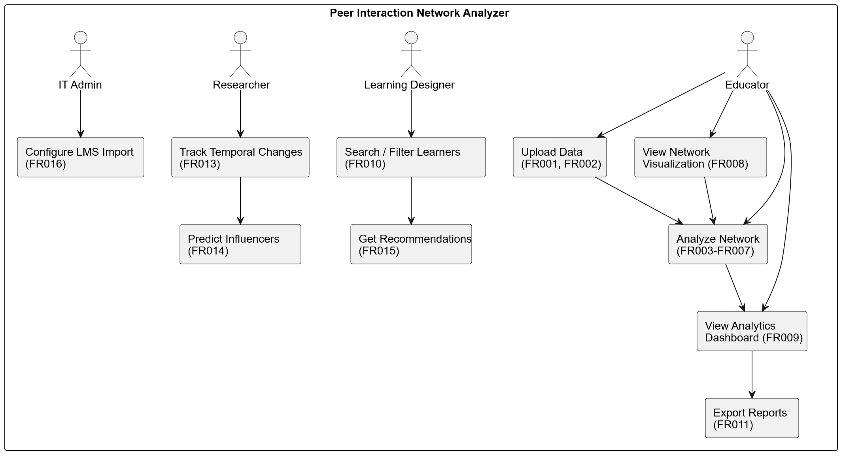

Use Case 1: Upload and Analyze Interaction Data

Field | Description
ID | UC001
Name | Upload and Analyze Interaction Data
Description | This use case describes the process of uploading peer interaction data and generating network analysis results
Requirement(s) | FR001, FR003, FR004, FR005, FR006, FR007
Actor(s) | Educator, Academic Administrator, Researcher
Precondition | Actor has interaction data file in CSV or Excel format
Postcondition | Network is analyzed and results are displayed in dashboard

Basic Flow:
1. Actor navigates to the application
2. Actor selects "Upload CSV/Excel" as data source
3. Actor uploads interaction data file
4. System validates file format and displays column options
5. Actor selects source column (student initiating interaction)
6. Actor selects target column (student receiving interaction)
7. Actor optionally selects weight column
8. Actor clicks "Analyze Network" button
9. System builds network graph from data
10. System calculates all centrality measures
11. System detects communities using Louvain algorithm
12. System identifies influential and isolated learners
13. System displays interactive network visualization
14. System shows analytics dashboard with results

Alternative Flow:
A1: Generate Sample Data
1. Actor selects "Generate Sample Data" instead of upload
2. Actor configures number of students (20-100)
3. Actor configures number of interactions (100-1000)
4. Actor clicks "Generate & Analyze"
5. Continue from step 9 in Basic Flow
Exceptions:
E1: Invalid File Format - System displays error message indicating accepted formats
E2: Missing Required Columns - System prompts actor to select valid columns
E3: Empty Dataset - System displays warning that no interactions were found
E4: Processing Error - System displays error details and suggests retry
Activity Diagram:
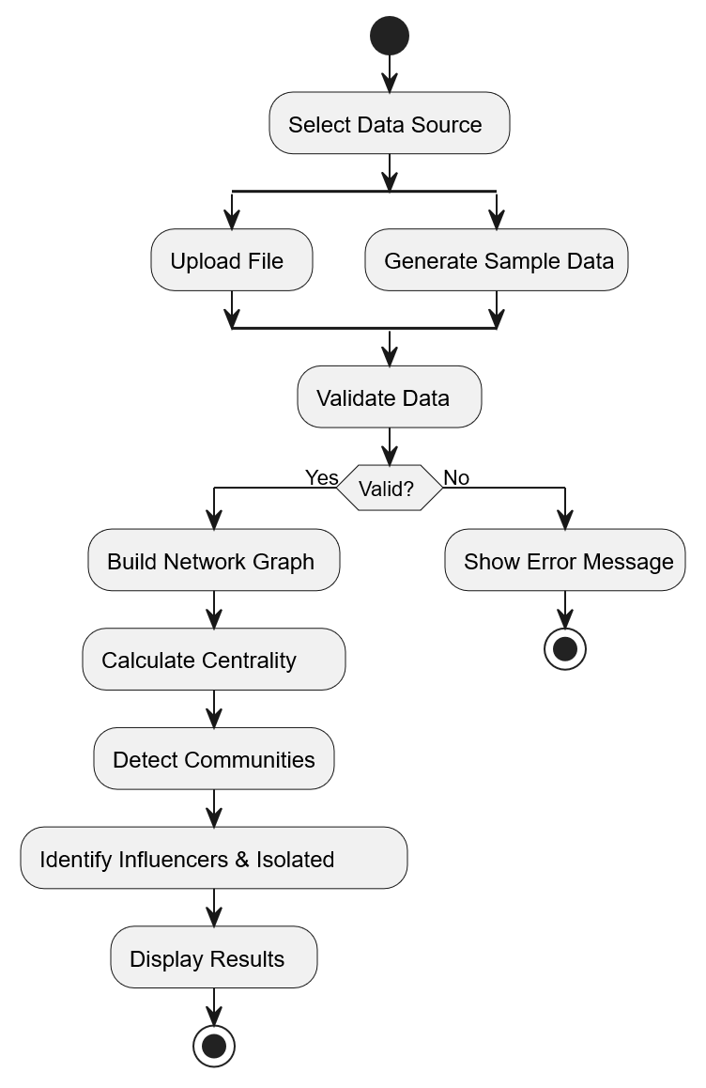
Use Case 2: View Network Visualization

Field | Description
ID | UC002
Name | View Network Visualization
Description | This use case describes how users interact with the network visualization to explore peer relationships
Requirement(s) | FR008
Actor(s) | Educator, Academic Administrator, Researcher
Precondition | Network analysis has been completed
Postcondition | Actor has explored the network structure

Basic Flow:
1. Actor navigates to "Network View" tab
2. System displays interactive network graph
3. Actor selects coloring option (by community or influence)
4. System updates node colors accordingly
5. Actor selects sizing option (by influence, degree, or uniform)
6. System updates node sizes accordingly
7. Actor hovers over nodes to view student details
8. System displays tooltip with learner ID, influence score, degree, and community
9. Actor zooms and pans to explore network regions
10. Actor identifies clusters and key nodes visually

Alternative Flow:
A1: Change Visualization Settings
1. Actor adjusts color/size options in sidebar
2. System re-renders visualization with new settings
Exceptions:
E1: Large Network Performance - System may simplify visualization for networks > 200 nodes

Use Case 3: Identify and Support Isolated Learners

Field | Description
ID | UC003
Name | Identify and Support Isolated Learners
Description | This use case describes how educators identify isolated students and receive intervention recommendations
Requirement(s) | FR007, FR015
Actor(s) | Educator, Learning Designer
Precondition | Network analysis has been completed
Postcondition | Actor has list of isolated learners with intervention strategies

Basic Flow:

1. Actor navigates to "Learner Analytics" tab
2. System displays isolated learners section with warning indicators
3. Actor reviews list of potentially isolated students
4. Actor notes connection counts and influence scores
5. Actor navigates to "Recommendations" section
6. System displays intervention recommendations for isolated learners
7. Actor reviews priority levels (high, medium, low)
8. Actor reviews suggested peer connections for each isolated learner
9. Actor reviews recommended activities to increase engagement
10. Actor implements chosen interventions in their course

Alternative Flow:
A1: Search for Specific Student
1. Actor uses search functionality to find specific learner
2. System displays individual learner details
3. Actor views personalized recommendations

Use Case 4: Track Influence Changes Over Time

Field | Description
ID | UC004
Name | Track Influence Changes Over Time
Description | This use case describes temporal analysis of influence patterns across multiple snapshots
Requirement(s) | FR012, FR013
Actor(s) | Educator, Researcher
Precondition | Multiple analysis snapshots exist for a dataset
Postcondition | Actor understands influence trends over time

Basic Flow:
1. Actor selects saved dataset from database
2. Actor performs analysis and saves snapshot
3. Actor repeats step 2 at later dates with updated data
4. Actor navigates to "Temporal Analysis" tab
5. System retrieves historical snapshots
6. System calculates influence trends for each learner
7. System displays influence timeline chart
8. Actor selects specific learners to track
9. System highlights selected learners on timeline
10. Actor views trend distribution (Rising, Stable, Declining)
11. Actor identifies emerging influencers
12. Actor identifies declining influencers needing attention

Use Case 5: Predict Future Influential Learners

Field | Description
ID | UC005
Name | Predict Future Influential Learners
Description | This use case describes using ML models to predict which students will become influential
Requirement(s) | FR014
Actor(s) | Educator, Learning Designer, Researcher
Precondition | Sufficient historical data exists (minimum 10 data points)
Postcondition | Actor has predictions for future influence with confidence scores

Basic Flow:

1. Actor navigates to "Predictions" tab
2. System checks for sufficient historical data
3. System trains prediction model on historical patterns
4. System displays model accuracy metrics
5. System generates predictions for all learners
6. Actor views current vs. predicted influence comparison chart
7. Actor reviews "Rising Stars" - students predicted to become influential
8. Actor reviews "At Risk" - current influencers predicted to decline
9. Actor views confidence levels for each prediction
10. Actor uses predictions to inform intervention strategies

Alternative Flow:
A1: Insufficient Data
1. System displays message indicating more snapshots needed
2. Actor continues collecting data over time

Use Case 6: Export Analysis Reports

Field | Description
ID | UC006
Name | Export Analysis Reports
Description | This use case describes exporting analysis results for external use
Requirement(s) | FR011
Actor(s) | Educator, Academic Administrator, Researcher
Precondition | Network analysis has been completed
Postcondition | Actor has downloaded report files

Basic Flow:

1. Actor navigates to "Reports" tab
2. System displays export options
3. Actor clicks "Download CSV" for learner metrics
4. System generates and downloads learner_metrics.csv
5. Actor clicks "Download Excel" for learner metrics
6. System generates and downloads learner_metrics.xlsx
7. Actor clicks "Download CSV" for community summary
8. System generates and downloads community_summary.csv
9. Actor clicks "Download JSON" for network statistics
10. System generates and downloads network_stats.json
11. Actor uses exported files in external tools or reports

4. References

1. Gašević, D., Jovanović, J., Pardo, A., & Dawson, S. (2017). Detecting learning strategies with analytics: Links with self-reported measures and academic performance. Journal of Learning Analytics, 4(2), 113-128.
2. Blondel, V. D., Guillaume, J. L., Lambiotte, R., & Lefebvre, E. (2008). Fast unfolding of communities in large networks. Journal of Statistical Mechanics: Theory and Experiment, 2008(10), P10008.
3. Holme, P., & Saramäki, J. (2012). Temporal networks. Physics Reports, 519(3), 97-125.
4. Baker, R. S., & Inventado, P. S. (2014). Educational data mining and learning analytics. In Learning Analytics (pp. 61-75). Springer, New York, NY.
5. Freeman, L. C. (1978). Centrality in social networks conceptual clarification. Social Networks, 1(3), 215-239.
6. Page, L., Brin, S., Motwani, R., & Winograd, T. (1999). The PageRank citation ranking: Bringing order to the web. Stanford InfoLab.
7. Hagberg, A. A., Schult, D. A., & Swart, P. J. (2008). Exploring network structure, dynamics, and function using NetworkX. In Proceedings of the 7th Python in Science Conference (pp. 11-15).
8. Pedregosa, F., et al. (2011). Scikit-learn: Machine learning in Python. Journal of Machine Learning Research, 12, 2825-2830.
9. IEEE Std 830-1998. (1998). IEEE Recommended Practice for Software Requirements Specifications. IEEE Computer Society.
10. Dawson, S., Tan, J. P. L., & McWilliam, E. (2011). Measuring creative potential: Using social network analysis to monitor a learners' creative capacity. Australasian Journal of Educational Technology, 27(6), 924-942.

